COMP 1451 Quiz #4
Instructor: Colleen Penrowley

 | Score: /12
Name: Alex Dai | Student Number: A00937175

COMP 1451 Introduction to Software Development 2
Quiz #4

Below is the interface to a Library class. Use this interface to answer the questions on the next page.

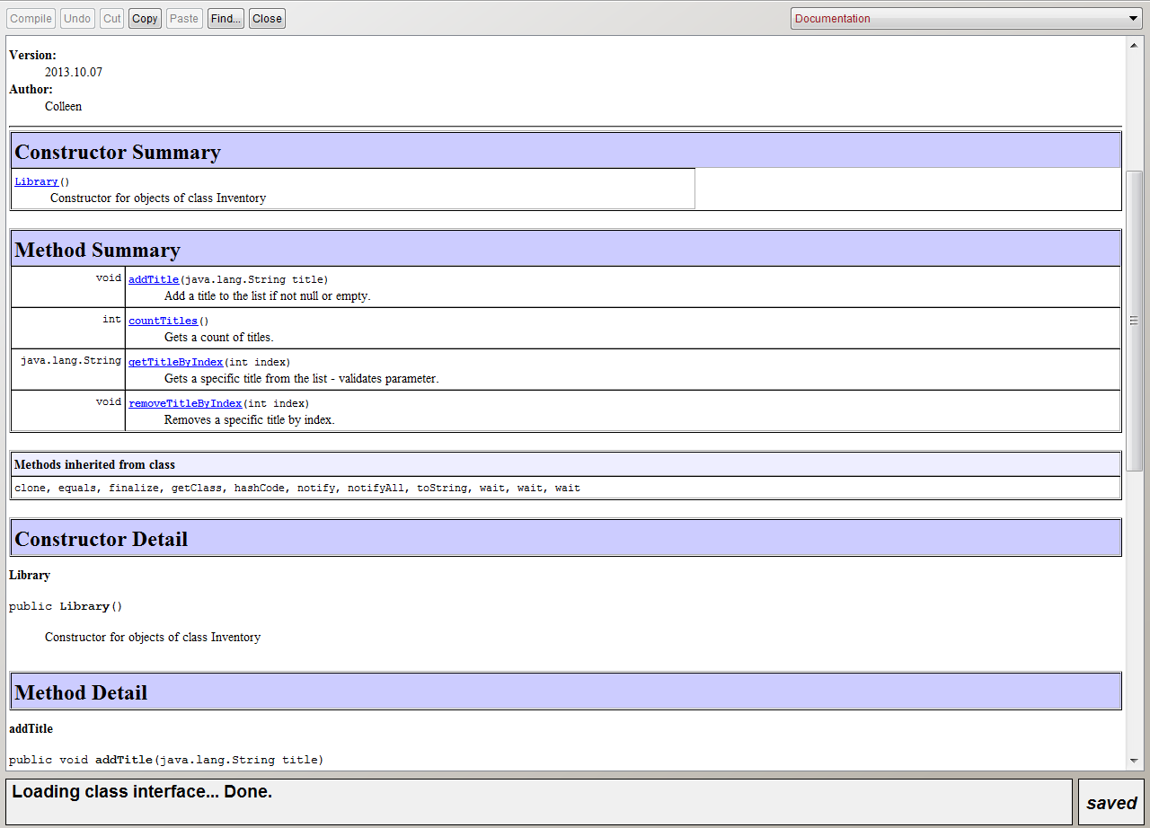

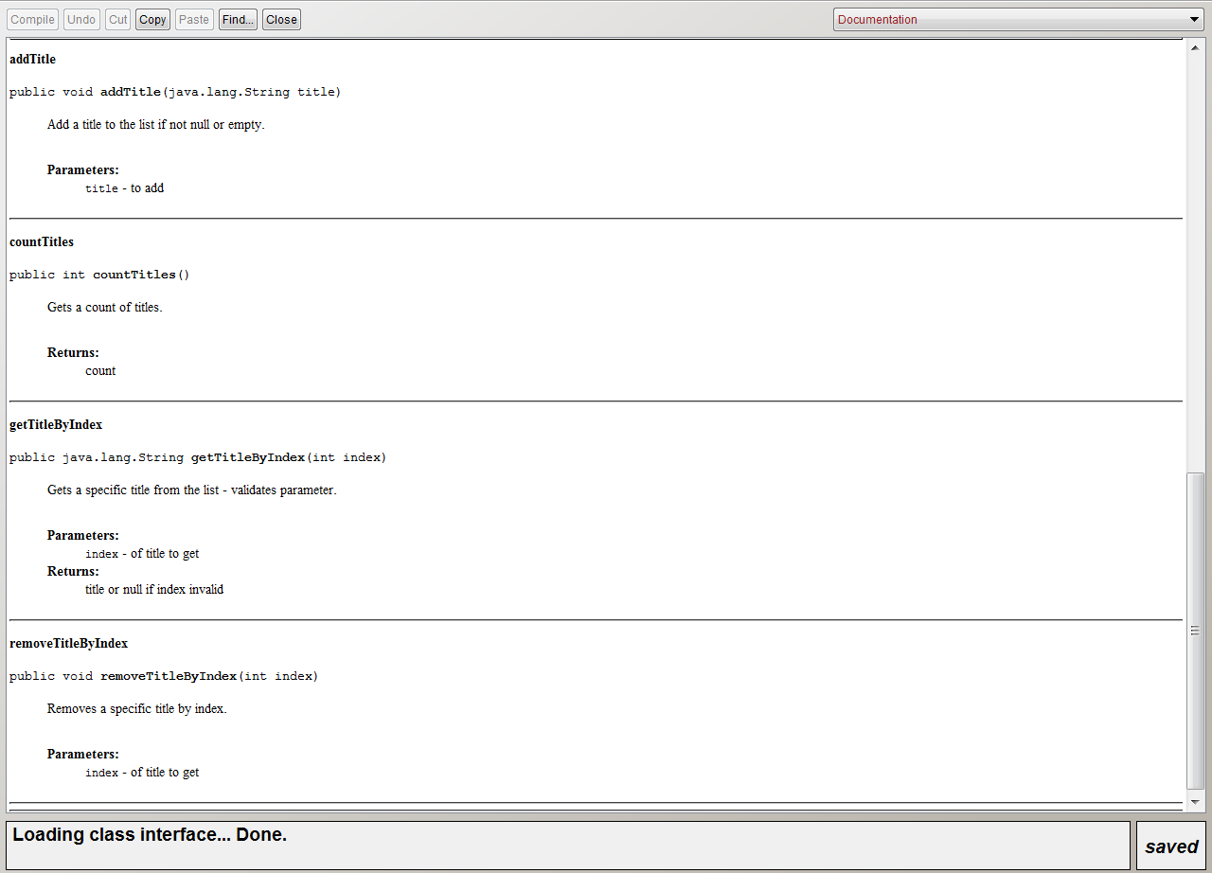

Assume that a test class exists for the Library class, and that it has this field and setUp() method :

private Library library1;

/** Sets up the test fixture.
*
* Called before every test case method.
*/
protected void setUp()
{
library1 = new Library();
}

Here is an example test method, appropriately-named.

@Test
public void testAddTitlePositive()
{
library1.addTitle("new book");
assertEquals(1, library1.countTitles());
}

- Write a different positive test for addTitle(String title) , one that does not use countTitles(). ( 2 points )

@Test
public void testAddTitlePositive()
{
library1.addTitle(“new book”);
assertEquals(“new book”, library1.getTitleByIndex(0));
}

- Write a negative test for addTitle(String title). ( 2 points )

@Test
public void testAddTitleNegative()
{
library1.addTitle(null);
assertEquals(0, library1.countTitles());
}

- Write a positive test for getTitleByIndex(int index). ( 2 points )

@Test
public void testGetTitleByIndexPositive()
{
library1.addTitle(“new book”);
String title = library1.getTitleByIndex(0);
asssertEquals(“new book”, title);
}

- Write a negative test for getTitleByIndex(int index). ( 2 points )
@Test
public void testGetTitleByIndexNegative()
{
library1.addTitle(“new book”);
String title = library1.getTitleByIndex(-1);
assertEquals(null, title);
}

- Write a positive test for removeTitleByIndex(int index). ( 2 points )
@Test
public void testRemoveTitleByIndexPositive()
{
library1.addTitle(“book1”);
library1.addTitle(“book2”);
removeTitleByIndex(1);
assertEquals(1, countTitles);
}

- Write a negative test for removeTitleByIndex(int index). ( 2 points )
@Test
public void testRemoveTitleByIndexNegative()
{
library1.addTitle(“new book”);
removeTitleByIndex(10);
assertEquals(1, countTitles);
}

